Starting the Program
The following files are needed in the same folder prior to playing Wen’s Battleships:
Turing File
- Battleship.t
Audio Files
- Hit.wav
- Miss.wav
- Winning Hit.wav
- Duel of the Fates.wav
To start the program, simply open Battleship.t and either click “Run” or press F1.

Program Description
Wen’s Battleships is a superior variation of the game Battleships and allows two players to battle on an 8 by 8 grid. Each player is given 8 ships of different kinds and sizes and the users are able to place them at different spots on the grid with flexibility. After the ships are set up, the players are able to attack each others’ ships, and whoever sinks all enemy ships will be declared the winner.
The program is able to function in different modes as well. It allows the game to be played in either keyboard or mouse mode. In the keyboard mode, all inputs are made by keys entered from the keyboard. In the mouse mode, all non-text inputs are made by the click of the mouse. The user can also decide whether to let the program show a ship has been sunk or not. If yes, the program will draw the perimeter of the ship as missed hits when it has been sunk. The perimeter (not diagonally) of the ship is not allowed to contain any other ships, therefore revealing a ship has been sunk tells the player there can be no ships in that ship’s perimeter. If not, the user might think the ship is longer, but it has already been destroyed, and is harder than normal. The game is also able to let the user choose whether to play background music or not during the set up of the ships.
Game Rules
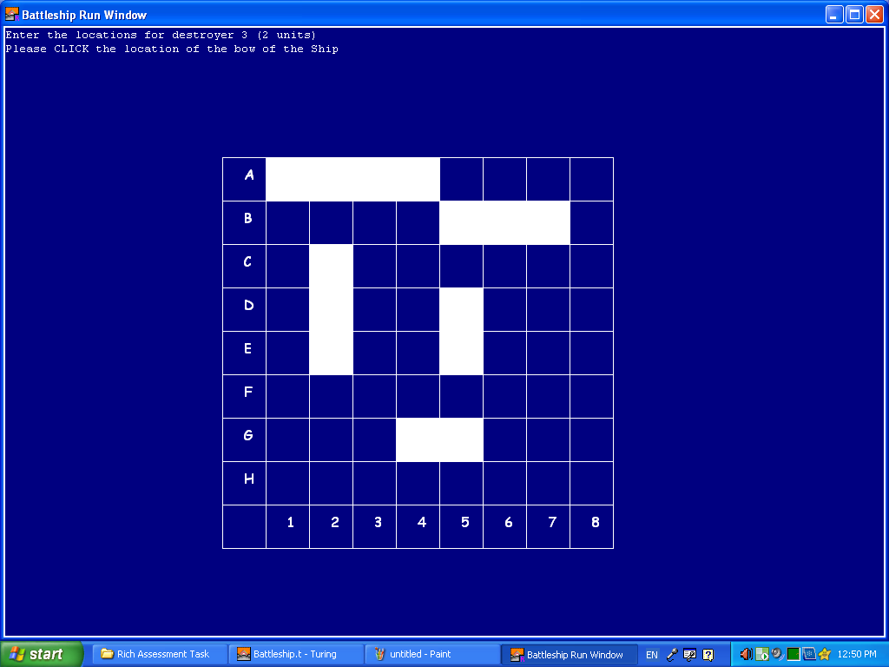
Ship Set up
See ship table
During set up, one player will set up his/her own ships at a time without the other seeing the location of this player’s ships.
Input Requirements
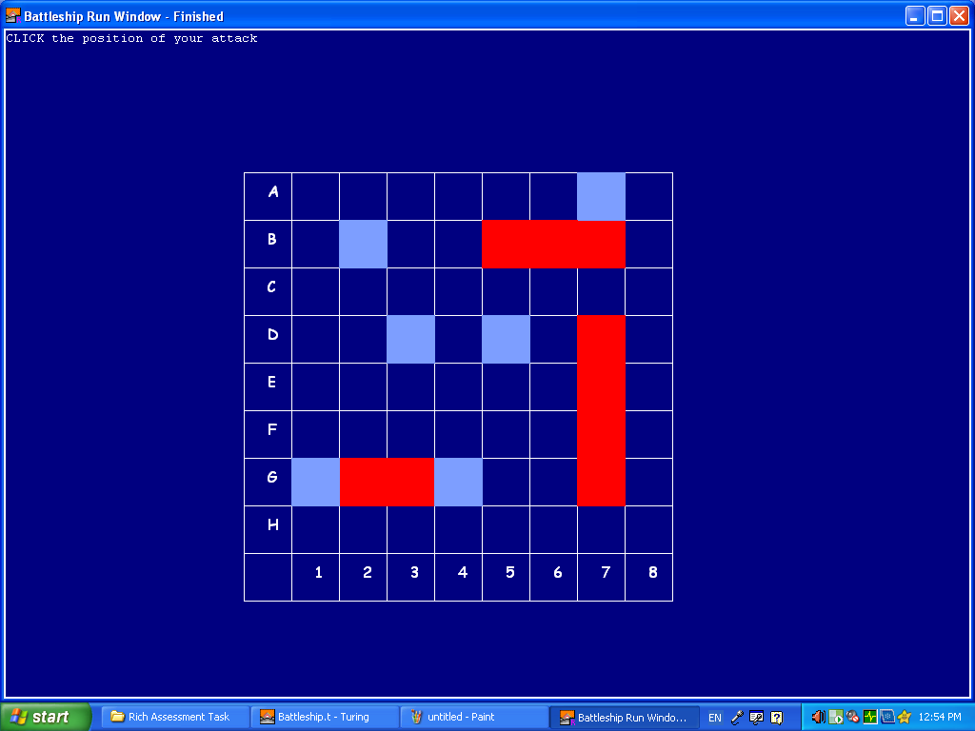
All ship coordinates must be on the grid. The ships must be positioned horizontally or vertically, never diagonally. The ships must be of required size for each type of ship. Different ships cannot be set up in the same coordinates. The ships cannot touch each other adjacently (does not include diagonal squares).
Attack
During attack, the two players can both observe the game screen as each player take turns guessing and hitting the other’s ships. If a hit is successful, the location of the attack will turn red to notify the hit, and the player gets an extra turn. If the hit was not successful, the location of the attack will turn light blue, notifying a miss, and the other player now has a chance to hit his/her ships. If the game was chosen to show a ship has been sunk, and all coordinates of a ship has been hit, its adjacent perimeter (not diagonally) will show as a missed hit if they are not already. When all ships of one player are sunk, the other player will win.
Input Requirements
All attack coordinates must be on the grid. Coordinates that are not dark blue (not attacked before) in colour cannot be inputted.

Game Controls
Please follow in-game instructions for all required inputs.
Keyboard Mode
To set up ships, simply enter the coordinates of the position of the bow (front) and the stern (back) of the ship you’re trying to set up in this fashion: (letter, number). E.g. E6
The letters range from A to H, the numbers range from 1 to 8
To attack, simply enter the coordinates of the desired attack location in the same manner.
Mouse Mode
To set up ships, simply click the squares of the position of the bow and stern of the ship.
To attack, simply click on the square of the desired attack position.
Exit the Program
To exit the program at any time, simply press the escape (Esc) button on the top left corner of the keyboard. The game will not be resumed at where it quit next time opened.

Ship Table
Ship Type | Ship Size | Number of Ships for each player
Battleship | 4 | 1
Cruiser | 3 | 2
Destroyer | 2 | 3
Submarine | 1 | 2

